

**Good policy vs accurate forecasts**

Speech given by

Gertjan Vlieghe, External MPC member, Bank of England

Bloomberg Headquarters, London Wednesday 5 April 2017

I would like to thank Rodrigo Guimarães, Jack Marston, Chris Redl, Clare Macallan, Simon Hayes, James Talbot, Michael Saunders, Marilyne Tolle, Thomas Belsham, Mike Peacock and Pavandeep Dhami.

1. Introduction

Although modern-day central bank communication typically involves making forecasts of growth and inflation1, I will argue that there is an important distinction to be drawn between good monetary policy and making accurate forecasts. There have been times when forecast errors were large, but monetary policy nevertheless improved outcomes significantly. There have been times when forecast errors were small, but policy did not respond as it should have. And there have been times, just recently, when forecast errors were small and policy was broadly right.

I will illustrate these points using the experience of the pre-crisis period in the mid-2000s, the post-crisis aftermath in 2008, and the period following the EU referendum in 2016. I will then reflect on implications for current and future policy.

None of this should be taken to mean that I am in any way complacent about forecast errors. Forecast errors might reveal missing ingredients in our models, or that key judgements need to be revised. Analysing forecast errors is therefore an important part of the MPC’s policy debate, and of the Bank’s internal process of updating and improving our analytical toolkit. But the existence of forecast errors per se, whether large or small, is not necessarily a sign of either wrong policy or of using the wrong framework. Sometimes forecast errors simply tell you things happened that could not have been foreseen.

Before getting into the detail of evaluating our past economic forecast errors and monetary policy decisions, I think a few analogies with medicine are helpful.

1. Medical analogy

Forecasting when a patient will have a heart-attack2 is difficult. No doctor can do this accurately. We only have an imperfect understanding of how the human body works, we have only partial information about what is going on “under the skin” at any point, and the human body is constantly hit by unanticipated shocks, such as disease or physical trauma, or a rapid change in the external environment.

Doctors nevertheless have a hugely important role to play, both before and after the heart attack.

Before the heart attack, doctors can tell a patient which factors contribute to increasing the risk of a heart attack. Some of these are beyond the patients’ control, such as old age. Some are entirely within the

1 It is easy to forget that using forecasts to communicate monetary policy, or indeed communicating monetary policy at all, is a relatively recent innovation. The Federal Reserve only began to announce that it had changed interest rates, and by how much, in the early 1990s. And the Bank of England started publishing its economic outlook in regular Inflation Reports only in 1993. See also Haldane (2017).

2 A heart-attack is a drastic and life-threatening event, but it seemed an apt analogy given how often the 2008 crisis has been described as a heart attack in financial markets or in financial institutions.

patients’ control, such as smoking. Some factors can be partially influenced by life-style and diet choices, such as high blood pressure, high cholesterol and diabetes.

After the heart attack, even one that was entirely unexpected, a doctor can perform life-saving procedures, such as administering blood-thinning medication, widening the coronary artery, or performing a coronary artery bypass.

The key point, as far as my analogy goes, is that doctors can make an important contribution to lowering the risk of a heart attack beforehand, and increasing the probability of survival once a heart attack has occurred. The ability of doctors to make these important contributions is not dependent on the doctor’s ability to forecast accurately when a patient will have a heart attack. That of course is not to say that attempting to forecast heart attacks is not a fundamental part of the progress in treating and preventing heart attacks.

Constantly examining past and new data is one way in which doctors learn better ways to prevent and treat them.3

Similarly, forecasting the macro-economy is hard. No economist can do this accurately, even if some get it right some of the time. We only have an imperfect notion of how the economy works, we only have partial information about the state of the economy at any point in time, and the economy is constantly hit by unanticipated shocks.

Despite this difficulty in forecasting, central banks make an important contribution to monetary and financial stability. Central banks can make adjustments to interest rates and macro-prudential tools during normal times to keep the economy on a sustainable trajectory, with growth close to trend and inflation close to target. This is about avoiding the crisis that we end up never experiencing, or reducing the fall-out from a recession that otherwise might have turned into a crisis.

And when a recession or financial crisis does hit, central banks can administer life-saving procedures such as very large cuts in interest rates, emergency liquidity provision and asset purchases to return the economy to good health as soon as possible, keeping medium-term inflation expectations anchored.

The success of central bank policies does not depend on having very accurate forecasts. Neither laying a sound basis for sustainable growth and stable inflation, nor responding quickly to an unfolding recession requires accurate macro-economic forecasts. Rather, they require a good diagnosis of the state of the economy, source of shocks hitting the economy and an understanding of the effects of available tools4.

3 The statistical techniques used to identify risk factors in heart failure closely resemble the techniques used by economists. A model is estimated on the data to test the hypothesis, for example, “is poor diet associated with higher incidence of heart failure, other things equal?”, in exactly the same way as a central bank might test the hypothesis “are higher house prices associated with higher consumption, other things equal?” or “is higher credit growth associated with incidence of financial crises, other things equal?”. See eg Califf and Pencina (2013), D’Agostino *et al* (2001).

4 A good diagnosis and understanding of the effects of available tools is precisely why central banks use so-called “structural models” of the economy, which provide estimates of what the effect of a particular policy change on the economy would be. We know these models

A good diagnosis and an understanding of the available treatments is of course also precisely the requirement for doctors to be able to contribute effectively to their patient’s health. But a good diagnosis and treatment does not translate into infallible forecasts, either in economics or in medicine.

Before examining the pattern of past policies and forecast errors, I would like to make a few general points about the precision and evaluation of economic forecasting.

1. What forecasting can and cannot do

First of all, despite our best efforts and intentions, forecast errors will always happen. We will never reach a point when we have no more uncertainty about how the economy works. There is, in other words, a level of uncertainty that is irreducible. This is because the economy is driven by rapidly adapting and evolving human behaviour, not a stable mechanical process. Moreover, changes in our understanding of the economy themselves feed back into changed behaviour, through changes in policies, laws and expectations. Hence our understanding of how the economy works will never fully catch up. This probabilistic nature of forecasting is not unique to economics, it is present in many natural sciences as well. Your doctor can only ever tell you that the risk of a heart attack is high or low, not when you will have a heart attack. A weather forecaster can only tell you that chance of rain is high or low, not when it is actually going to rain. The doctor analogy is more apt than the weather analogy, because weather forecasters do not influence the weather, whereas doctors do influence your health, and central banks do influence economic outturns.5

The principle that there is an irreducible uncertainty in economic forecasting also implies that we should be humble about our ability to forecast the next financial crisis or the next recession. The economy is likely to evolve in ways that we will only belatedly come to understand. And while we are unlikely to experience a financial crisis of the exact type we have just witnessed for – I hope – many decades, it would be hubris to think that no crisis of any type can ever happen again. It is precisely such hubris that tends to precede the next crisis.6 Our contribution is to warn about increasing risks in advance, so that households, businesses and financial institutions are more cautious, and policymakers put regulatory firewalls in place, which will itself reduce the risk of a crisis actually happening. But, given a history of many centuries of financial crises,7 we must also allow for the possibility that a collective failure to imagine how it could all go wrong will one day lay the groundwork for the next crisis. If we can forecast it, it is less likely to happen. If it does happen, it is probably because we did not see it coming.

are inferior in terms of pure forecasting performance to unidentified “reduced-form models”, which simply aim to provide the most accurate statistical forecast without specifying the underlying economic mechanisms at work. Our aim is not forecast accuracy per se, our aim is understanding the mechanisms at work.

5 Incidentally, just as economists have debates about the need for better models, so do doctors. A recent editorial in a cardiology journal lamented that “many centres or groups develop their own models, each of which is necessarily based on a limited sample […] The field

would benefit substantially if these efforts were united around the goal of creating a comprehensive, generalizable, well-validated model” (Califf and Pencina (2013)).

6 Minsky’s (1986) theory of financial instability featured the idea that periods of calm can plant the seeds of the next crisis, by increasing complacency about debt. See Brunnermeier & Oehmke (2013) for a review of theories of crisis.

7 See, e.g. Kindleberger (1978), Chancellor (1999) and Reinhart & Rogoff (2009).

While forecasting is a messy business that involves judgement as well as models, forecast *evaluation* is actually quite precise. A widely used framework is that a good forecaster is one who satisfies two criteria: (1) she must be unbiased, which means not systematically overpredicting or underpredicting; (2) she must be efficient, which means not systematically leaving useful information unexploited.

In a detailed study of the Bank’s forecast errors, The Independent Evaluation Office show that the

Bank of England’s forecasts for, for example, GDP growth a year ahead8 indeed satisfy the two criteria of being unbiased and efficient. It also turns out Bank of England forecasts are about as good as those of private sector forecasters, and are about as good as other central banks’ forecasts of their own economies. Bank of England forecasts are also systematically better than guessing,9 or asking a chimp, despite what some commentators would have you believe.

It is only these formal forecast evaluations over long periods of time, and in comparison to other forecasts made in real time, without the benefit of hindsight, that tell us whether forecasts are any good. Using, as some commentators do, the fact that recent GDP outturns were stronger than expected as evidence that all economic forecasts are useless, falls into exactly the same logical trap as arguing that medical evidence of the dangers of smoking is useless because you know someone who smoked two packs per day and lived to be ninety years old.

1. Forecast accuracy and policy effectiveness

I am not saying that good forecasts are unimportant. Central banks publish their forecasts to provide public accountability for their actions: to explain why monetary policy has been set a certain way, and how that is going to contribute to meeting the inflation target. This allows the public to understand our policy reaction function, which in turn improves the transmission mechanism of monetary policy, by allowing households and firms to form expectations of how the central bank will respond to future economic circumstances, even ones which are not currently anticipated.10

Rather, I am saying that monetary policy can do its job even if there are large forecast errors. And I will go one step further, which is to say that larger forecast errors do not imply worse monetary policy, nor do small forecast errors imply better monetary policy.

Chart 1 shows the history of the Bank’s forecast errors for GDP at various horizons.

8 Results for other variables and other forecast horizons are broadly similar.

9 The IEO compares the accuracy of Bank forecasts to those of a random walk model, which is the model you would use if you thought there was no point in models, and guessed that the next outturn was going to be the same as the previous outturn.

10 See Woodford (2013) for a detailed discussion of the role of central bank forecasts in communicating the policy reaction function.

Note that, perhaps counterintuitively, the fact that policy affects the economy with a lag is not one of the reasons why central banks make forecasts. As Giannoni and Woodford (2003) show, optimal monetary policy can still be defined in terms of a response to the current state of the economy, rather than a forecast. The more forward-looking economic agents are, the less forward-looking the central bank needs to be.

# Chart 1 – GDP growth forecast errors

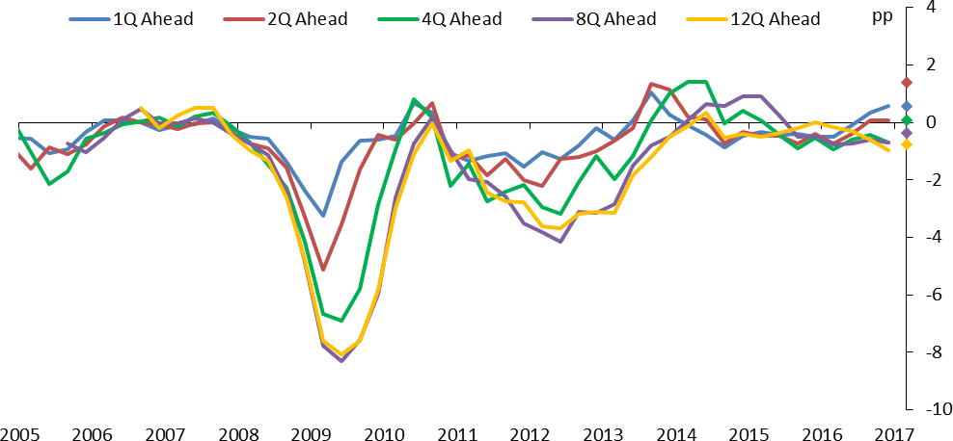

Notes: For each horizon, the chart shows the outcome minus Bank of England Inflation Report forecasts of quarterly yoy growth rate (in percentage points) for the date shown. For example the ‘12Q Ahead’ forecast errors for 2009Q1 are based on forecasts made in the February 2006 IR. The diamonds represent the forecast errors assuming quarterly growth in 2017 Q1 of 0.6%, the nowcast published in the March MPC Minutes.

Before the crisis, in the mid-2000s, forecast errors were quite small. It was, after all, the period called “the Great Moderation” at the time.11 Does that mean that policy was set perfectly? Not at all. As has been discussed widely since then, in focusing too narrowly on inflation, policymakers in the UK and in other major developed economies failed to take action to limit the rapid expansion of credit that ultimately contributed to the deepest recession in 2008-09 that the UK had experienced since the Great Depression12. It is a point of debate whether this was a failure of regulatory policy (too lax) or of interest rate policy (too low),13 and I believe it was largely the former. But what is clear is that little or no action was taken on either front. Small forecast errors did not imply good policy. The medical equivalent would be that your doctor did not tell you to quit smoking and improve your diet, thereby missing an important opportunity to lower the risk of a heart attack at some uncertain future date. Just because you did not have a heart attack for many years, does not imply that it was a good decision for the doctor to let you keep smoking and eating badly.

As the financial crisis unfolded, and started to have material consequences for the real economy in 2008, forecast errors were very large indeed. At its deepest trough, GDP was seven percentage points weaker than had been forecast just four quarters earlier.

11 See Stock & Watson (2002) and Bernanke (2004).

12 Excluding World War II, and as measured by the peak-to-trough contraction in GDP, using ‘Three centuries of macroeconomic data’ <http://www.bankofengland.co.uk/research/Documents/datasets/threecenturies_v2.3.xlsx>

13 Interest rates were not the ideal tool to lean against excessive credit growth, but the Bank did not have the macro-prudential tools it

now has. Central banks could either have leaned against credit growth, or have leaned on regulators. See King (2013), Bean (2014) and Carney (2014).

But let us consider the policy response to the financial crisis. The Bank of England cut interest rates by

4 ½ percentage points, provided emergency liquidity facilities, purchased government bonds to add further stimulus when interest rates reached their effective lower bound, and, together with the government, devised a bank recapitalisation plan to restore trust in the financial system. And all of this took place in the space of a few months after the collapse of Lehman Brothers.

This policy, I believe, prevented the recession from turning into a depression.14 By the second half of 2009 the economy was growing again.

# Chart 2 – Inflation forecast errors

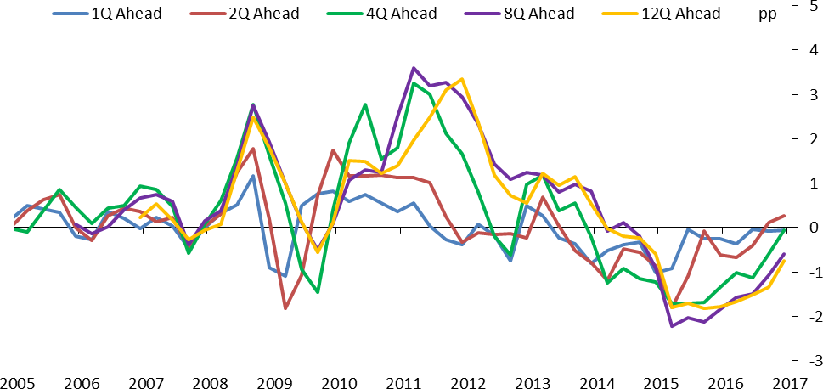

Notes: For each horizon, the chart shows the outcome minus Bank of England Inflation Report forecasts of quarterly yoy growth rate (in percentage points) for the date shown. For example the ‘12Q Ahead’ forecast errors for 2009Q1 are based on forecasts made in the February 2006 IR.

Chart 2 shows the Bank’s forecast errors for inflation. We also made large forecast errors on inflation, but in the opposite direction to the forecast errors on GDP. At the time, the policy narrative was that high inflation was caused by temporary factors (higher oil prices, increase in VAT, weaker exchange rate), and that substantial slack in the economy justified looking through those temporary factors when setting monetary policy. The temporary factors turned out to be significantly more persistent than expected. But even with hindsight, the diagnosis that underlying inflation pressures remained weak, so the economy did not require tighter monetary policy, proved correct.

Chart 3 shows the forecast errors of inflation against changes in the oil price. A large share of the inflation forecast errors were driven by oil price changes, most of which are unanticipated. This is a good example of

14 See also Del Negro *et al* (2017).

forecast errors that are driven by unanticipated events, not by misjudgements or missing ingredients of the model.

# Chart 3 – Inflation forecast errors and oil price changes

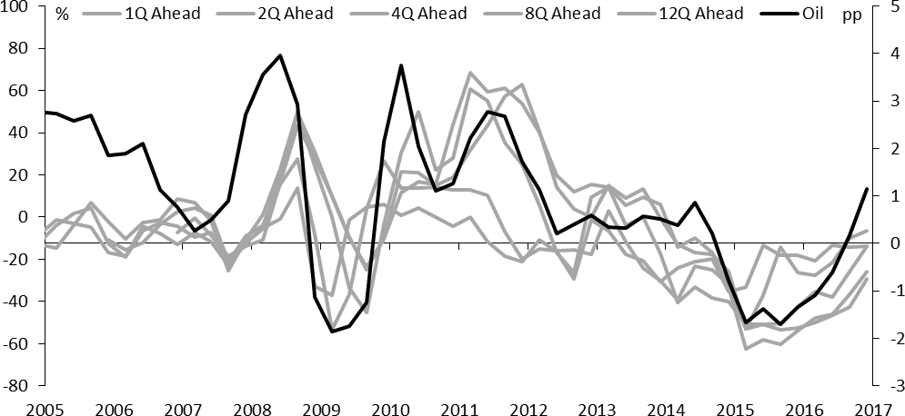

Notes: In addition to the CPI forecast errors shown in Chart 2 (in grey lines, right scale), the chart shows percentage change of 3month average on 3 month average 12months earlier in oil prices (on left scale).

Despite large GDP and inflation forecast errors in the 2008 crisis period and its aftermath, I would argue that monetary policy was highly successful, responding quickly to unfolding events, and effectively putting a floor under the downward spiral of asset prices and economic activity that had begun to take hold. Just as a doctor does not need to predict your heart attack in order to respond to it effectively, monetary policy does not need to forecast a recession several quarters in advance to respond to it effectively.

The success of central bank responses to the financial crisis owed a great deal to learning from past forecast errors, in particular learning from the Great Depression. Two policy choices that were made in the US in the early 1930s are now widely considered to have been a mistake, and contributed to the depth of the depression. One was the failure to ease monetary policy sufficiently, which was in turn driven by a misplaced desire to remain on the gold standard.15 The other was the decision to let so many banks fail, which resulted in total loss of confidence in the financial system, and a downward spiral of asset prices and economic activity on a scale rarely seen up to that point or since then.16

Both of these errors were avoided in 2008: monetary policy was loosened dramatically, and confidence in the financial system was shored up via a range of liquidity measures and bank recapitalisations. Of course, we did not learn all of the lessons of the past. If we had, we would also have learned to be more concerned

15 See Bernanke & James (2000)

16 Friedman and Schwartz (1963)

about the pre-crisis leverage build-up, and find ways to lean against it. But at least we did not compound the effect of the pre-crisis policy mistake with post-crisis policy mistakes, as happened in the early 1930s. So the period of small forecast errors was one when policy makers made costly mistakes by not realizing the dangers that were building up, while the period of large forecast errors was one of the best examples of the usefulness of modern central banks, thanks to important lessons learned from policy mistakes 80 years earlier.

1. Forecasting around the time of the referendum

Let me now turn to the forecast errors and policy in the period since the referendum. Economic growth has been better in the immediate post-referendum period than we and nearly everyone else had expected.

We have gone from expecting a short and sharp slowing, to pencilling a much milder and more protracted slowing. Throughout this period of forecast revisions, we have remained more optimistic than most private sector forecasters. Both the upward revision in forecasts and the gap between the Bank and consensus are shown in Chart 4.

# Chart 4 – Evolution of forecasts for GDP growth in 2017

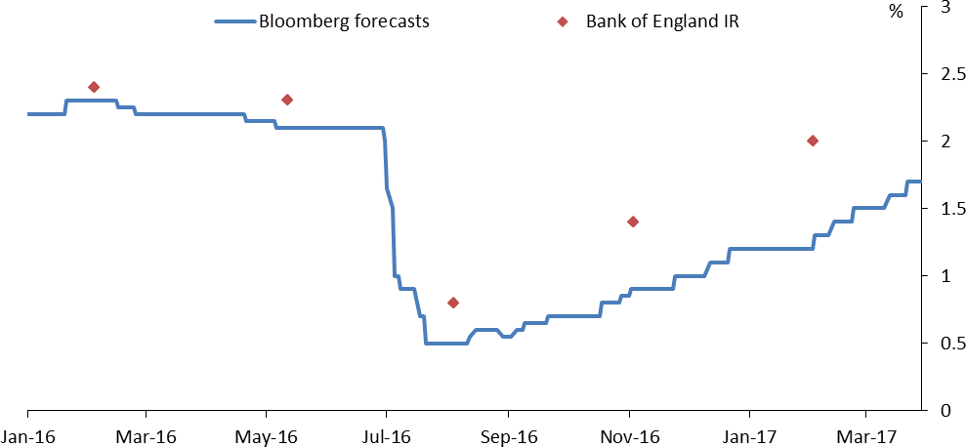

Notes: Forecasts for calendar year growth rate in GDP for 2017. Median of Bloomberg survey of economists and Bank of England Inflation Reports.

Why did we expect such a sharp slowing back in August? First and foremost, short-term indicators of the economy, such as business surveys, consumer confidence, housing indicators, had turned down sharply. We always monitor published data that, historically, has given a decent but not perfect signal of where the economy is heading in the near term (see Chart 5). And these data were falling rapidly in the immediate aftermath of the referendum. For example, the Composite PMI, an indicator of business activity growth, had fallen to its lowest level since 2009. And the RICS New Buyer Enquiries balance, an indicator of housing

activity, had fallen to its lowest level since 2008. In fact, some of these indicators were in outright recession territory. But allowing for the fact that they sometimes over-react to short-term events, we aimed higher than the indicators were suggesting, and our central forecast was for a marked slowdown, but not a recession.

# Chart 5 – GDP growth and PMI composite

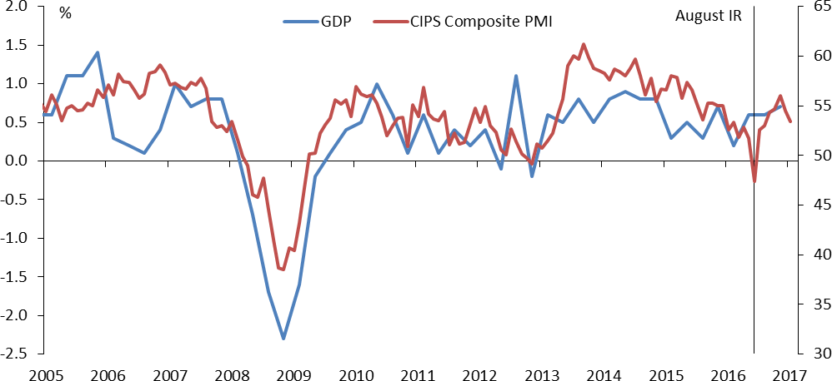

Notes: GDP quarterly growth rate (left scale) and the CIPS Composite PMI (index, right scale). Stalk shows PMI data available at the time of the August 2016 Inflation Report.

Second, we noted the spike in various measures of uncertainty. The historical relationship between measures of uncertainty and economic growth implied that an uncertainty spike of the size we saw after the referendum was expected to lead to a sharp slowing in demand. There are many ways of measuring uncertainty, and different measures give you different forecasts of demand growth,17 but all of them implied a sharper slowing than we have actually experienced.

My main point regarding our August forecast is that we were not possessed by some innate feeling of gloom, nor were we beholden to one particular model of the economy that we thought would give us the right answer at all times. Rather, we were responding to actual published data on economic activity and uncertainty that was pointing to a sharp slowing in demand.

Based on the real-time assessment that the economy was slowing, we put in place a stimulus package in August, of a 25bp Bank Rate cut, a funding scheme to make sure the rate cut was passed on, additional gilt purchases, and corporate bond purchases.

17 See Forbes (2016).

As I noted at the time,18 I already saw considerable weakness in nominal growth as we headed into the referendum, and I was starting to think the economy might need more stimulus even in the status quo scenario of a remain vote. Based on the early economic indicators after the referendum, it was therefore an easy decision for me to decide that more stimulus was warranted. I thought our August package would be the start, and further stimulus would be needed.

From around early August, the indicators of economic activity that had fallen so sharply in June and July started recovering, and measures of uncertainty started falling back.

Even ex post, it is hard to know with precision what drove that improvement in the data. I will offer four possible reasons.

First, political uncertainty was resolved much sooner than everyone expected. By mid-July we had a new prime minister, something that was initially expected only in September. Moreover, the new PM made it clear that article 50 would not be triggered immediately, contrary to earlier expectations. Businesses realised that it would take years before the UK’s trading relationship with the EU might actually change.

Second, the outlook for fiscal policy changed. Before the referendum, there was talk of additional austerity should there be a vote to leave. After the referendum, the new government spoke of a “fiscal reset”,19 suggesting a looser stance, which was confirmed in the Autumn Statement.

Third, our own policy package did make a difference. Early communication by MPC members, and then action, stabilised sentiment.20 The rate cut was fully passed on. Gilt purchases started to have their desired effect of lowering real yields while re-anchoring inflation expectations which had been too low. And the corporate bond programme lowered corporate bond spreads significantly and spurred new issuance. This effectively prevented the uncertainty spike from manifesting itself in a tightening of financial conditions, which is a key channel via which uncertainty can affect the economy.

Fourth, completely unrelated to UK developments, the global economy started picking up in the summer, as evidenced by a range of global surveys, and the pick-up in commodity prices. This in turn fed back positively onto the UK economy, via foreign demand, confidence, and easier financial conditions.

Note that, in the context of historical forecast errors, the forecast errors in the past few quarters have been rather small, as chart 1 clearly shows. I have been quite puzzled by the repeated attacks on economic experts, forecasters and models, based on these relatively small forecast errors. Dismissing experts in general, and attacking the expertise of the economics profession as a whole, is a worrying and dangerous

18 See Vlieghe (2016a,b).

19 Comments by Philip Hammond on 22 July 2016, see [http://www.bbc.co.uk/news/business-36864099.](http://www.bbc.co.uk/news/business-36864099)

20 Carney (2016a) statement 24 June, Carney (2016b) speech 30 June, MPC minutes 14 July, Vlieghe (2016b) article in the FT on 17 July, and Weale (2016) interview.

development. Debate is always welcome, but it should be based on clearly articulated arguments and evidence. Otherwise, we risk making counterproductive decisions if prevailing evidence is simply ignored. Returning to my forecasts vs policy theme, even if our growth forecasts have so far turned out slightly too pessimistic, how do we evaluate the monetary policy response based on these forecasts? Some of the improvement in the outlook is likely to be due to our early and decisive monetary policy action, along with intensive financial stability contingency planning. Is anyone seriously arguing that things would have turned out better if policymakers had worried less, and taken no measures to add stimulus to the economy? I stand by those August decisions entirely. I would take exactly the same action again if faced with the same circumstances.

1. Outlook for economy and monetary policy

Monetary policy aims to hit the inflation target of 2% CPI. In recognition of the fact that it takes time for changes in monetary policy to have their full effect on the economy, the MPC generally tries to respond to *medium-term* inflation pressures, rather than short-term movements in actual inflation. Moreover, the horizon over which we aim to return inflation to target can vary in circumstances where economic shocks push growth and inflation in opposite directions, as we think is the case at the moment. To inform the medium- term inflation outlook, I want to highlight two significant current themes, namely exchange rate pass-through and wage pressure.

On a trade-weighted basis, sterling is down nearly 20% since its local peak in late 2015, and 12% since the referendum itself. Based on past experiences, we expect that to push up import prices, and, in turn, to push up consumer prices. While the exchange rate movement is quick, the pass-through to consumer prices is not. Given hedging practices, long-term pricing contracts, and lengthy supply chains, it takes several years for the pass-through to have its full effect. Our February central forecast was for inflation to rise to close to 3% around the turn of the year, before coming down slowly, but still above target at the end of our forecast period due to the persistent effects of the exchange rate.

# Chart 6 – Wage forecast errors

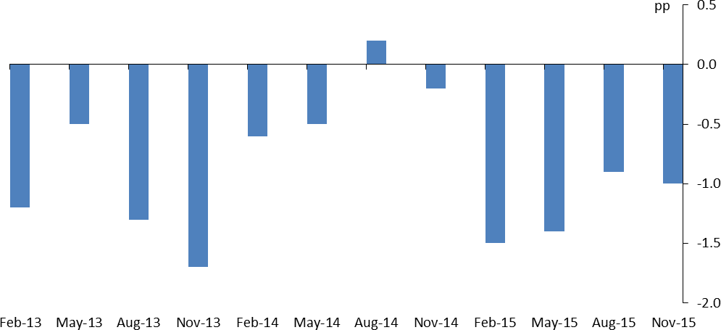

Notes: MPC forecast errors for wage growth one year ahead (four-quarter whole-economy AWE growth).

The second inflation theme is wages. Despite the fact that the unemployment rate has come down from its peak of 8.5% in 2011 to 4.7% on the most recent data, wage data continues to surprise us on the downside, and has done so persistently for several years (see Chart 6). Let’s be clear, wage growth *has* picked up somewhat from the sub-1% pace in 2013 and 2014, but not nearly as much as we had expected, given the fall in the unemployment rate. On the most recent data, it is barely above 2%, with no sign of sustained upward momentum yet (see Chart 7). There are two categories of explanations for subdued wage growth.

The first is that we have only recently emerged from a lengthy period of near zero headline inflation, from early 2015 until mid-2016. Low headline inflation means that a given nominal pay increase implies a larger real pay increase, so it plausibly lowers nominal pay demands for a period. If this is the main explanation for subdued wage growth, we might expect a reasonable pick-up in wage growth this year and next year, as pay negotiations will take place against a background of inflation heading towards 3%.

# Chart 7 - Whole economy regular wage growth

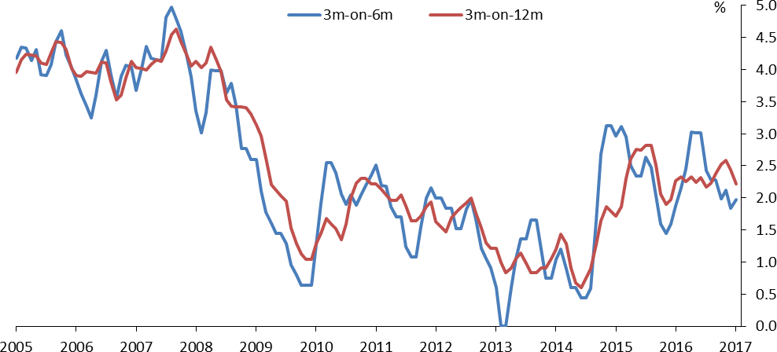

Notes: Growth rate of whole-economy AWE excluding bonuses, 3 month average over 3 month average 6 months or 12 months before (per cent).

But we have been experiencing weaker than expected wage growth for longer than inflation has been near zero, so this is unlikely to be the only explanation, and, in my view, perhaps not even the dominant one.

A second reason for subdued wage inflation is that there may be more slack in the labour market than the 4.7% unemployment rate would suggest. Involuntary part-time and self-employed workers, the threat of future job losses due to automation, demographic changes,21 all work in the direction of leading to less upward wage pressure for a given level of unemployment. To try and incorporate some of these changes to labour market into our forecast, the MPC revised down its collective estimate of the natural rate of unemployment in February, to 4.5%.22 There is a lot of uncertainty around that, in either direction.

If more slack, rather than a recent experience of low inflation, is the main explanation for subdued wage pressure, we might not see a significant change in wage pressure in the coming years, especially if growth slows somewhat, along the lines of our February forecast, or the weaker private sector forecasts.

The bottom line is that, despite better than expected growth, we have not had higher than expected underlying inflation pressure. Inflation is set to rise, but that seems entirely accounted for by exchange rate pass-through, which, although persistent, will ultimately fade as long as inflation expectations remain well anchored. Wage pressure has continued to surprise us on the downside.

21 See also Saunders (2017).

22 The repeated wage forecast errors in the same direction are an example of forecast errors that require action, as they reveal an aspect of the economy we seem to have misjudged. Our recent revision of the natural rate of unemployment has been a response to these repeated forecast errors.

# Chart 8 – Household consumption growth and real (post-tax) income growth

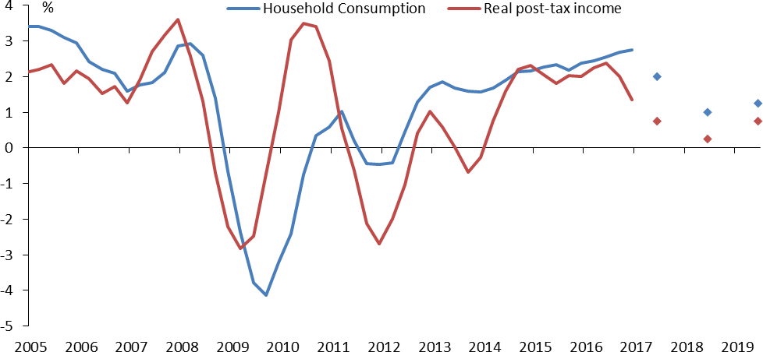

Notes: Annual growth rates (per cent) and forecasts from Table 5.D (page 36) in February 2017 Inflation Report.

The impact on household income of these two forces, namely exchange rate pass-through and subdued wage inflation, is substantial. Until mid-2016, inflation was close to zero, courtesy of the earlier drop in oil prices and the strength of sterling. That meant that real household labour income growth was close to 3%, despite subdued nominal wage growth. We now expect real household income growth to slow to around zero (shown in Chart 8), a big shift.

Recent retail sales data, though volatile, have started to show signs of slowing (Chart 9), after persistently surprising us to the upside for most of last year. Other household indicators, such as consumer confidence, car sales, housing indicators, are still more resilient, but many are nevertheless on a gradual downward trajectory over the past few months. My interpretation is that households are now responding to the change in real income growth.

What does all of this mean for monetary policy?

Given the low level of interest rates currently, and given that asset purchases are an imperfect substitute for policy rate changes, I do not think the MPC has as much room to ease as to tighten, i.e. there is an asymmetry. My view is that, in such circumstances, a rate hike that turns out to be premature is a more serious mistake than one that turns out to be somewhat late. Caution is warranted.

The consumer slowdown, which initially did not materialise, now appears to be underway. Given the hit to real income from a mix of subdued wage growth and rising inflation, I think the slowdown is more likely to intensify than fade away.

# Chart 9 – Household consumption growth and retail sales

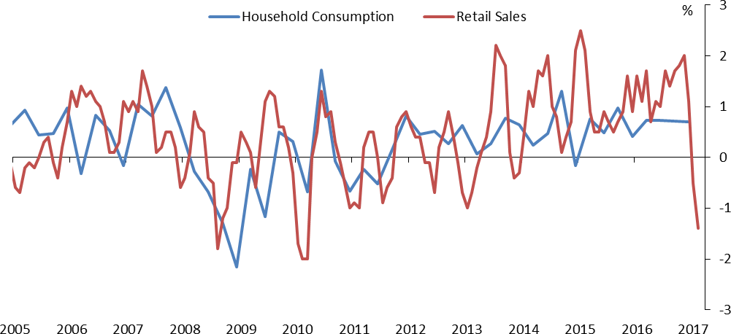

Notes: Quarterly consumption growth rates and 3 month average on previous 3 months ONS retail sales growth (per cent).

Although my interpretation of the consumption data is that a slowing has begun and is likely to intensify, that does not mean there are no upside risks. Consumer credit growth has been accelerating over the past few years, and has accelerated further in the second half of last year, suggesting that the resilience of household spending was in part financed by credit, and might persist for longer than expected. If strong credit growth continues, I would see it as a sign that monetary policy is too loose: in the absence of a consumption slowdown, there is less prospective economic slack, and therefore less justification for tolerating

above-target inflation at the forecast horizon. The average consumer credit flow of past three months has fallen back, and has been the weakest for over a year. So perhaps a slowdown in credit growth is already underway. But I will be alert to any signs of re-acceleration.

Concerning the outlook for business investment, the two-year clock on the renegotiations of the UK-EU relationship is now ticking. In the immediate aftermath of the referendum, firms did not react to the uncertainty by cutting spending sharply. Business investment growth has been about zero. Not great, and in fact the weakest we have seen since 2010, but not the sharp contraction we had feared either. It is possible that the absence of a sharp reaction was due to the fact that firms have generally taken a benign view of the impact on their business of possible future changes in the UK-EU relationship. It is also possible that uncertainty about these changes is substantial, but the changes have been too far away to have a marked effect spending decisions so far. As the time horizon now shortens, a more material reaction of spending in response to uncertainty might still occur. Much will depend on the detail of the final agreement, which might not be known until late in the negotiations.

In conclusion, a cautious strategy on interest rates is warranted, but only for as long as there is slack in the economy and underlying inflation pressures remain subdued. For now, taking together indicators of wages and inflation expectations, that seems to be the case. If, on the other hand, I see signs that inflationary pressures are spreading beyond just exchange-rate pass-through, or I see a re-acceleration of indicators related to household spending and credit, that would be my cue that a slightly higher level of Bank Rate is warranted.

# References

**Bean, C. (2014).** ‘The future of monetary policy’, speech available at: <http://www.bankofengland.co.uk/publications/Documents/speeches/2014/speech729.pdf>

**Bernanke, B. (2004**). ‘The Great Moderation’. February 20 2004 speech available at federalreserve.gov

**Bernanke, B. and H. James (2000)**, “The Gold Standard, Deflation, and Financial Crisis in the Great Depression: An International Comparison”, in Bernanke, B., *Essays on the Great Depression*, Princeton University Press.

**Brunnermeier, M. and M. Oehmke (2013). ‘**Bubbles, financial crises, and systemic risk’. *Handbook of the Economics of Finance, vol. 2*. Constantinides, M.H., Stulz, R.M. (Eds.), North Holland Elsevier, Oxford,pp. 1221–1288.

**Califf, R. and M. Pensina (2013).** ‘Predictive Models in Heart Failure: Who Cares?’, *Circulation: Heart Failure, 6: 877-878.*

**Carney, M. (2014).** ‘One Mission. One Bank. Promoting the good of the people of the United Kingdom’, speech available at: <http://www.bankofengland.co.uk/publications/Documents/speeches/2014/speech715.pdf>

**Carney, M. (2016a).** Statement from the Governor of the Bank of England following the EU referendum result, available at <http://www.bankofengland.co.uk/publications/Pages/news/2016/056.aspx>

**Carney, M. (2016b).** ‘Uncertainty, the economy and policy’, speech available at <http://www.bankofengland.co.uk/publications/Documents/speeches/2016/speech915.pdf>

**Chancellor, E. (1999).** ‘Devil Take The Hindmost: A History of Financial Speculation’, *Macmillan*.

**D’Agostino, R., S. Grundy, L. Sullivan, P. Wilson and CHD Risk Prediction Group (2001).** ‘Validation of the Framingham coronary heart disease prediction scores: results of a multiple ethnic groups investigation’, *JAMA, vol. 286, pg. 180-187.*

**Del Negro, M. G. Eggestsson, A. Ferrero and N. Kiyotaki (2017).** ‘The Great Escape? A Quantitative Evaluation of the Fed’s Liquidity Facilities’, *American Economic Review, vol. 107 (3), pg. 824-857.*

**Forbes, K. (2016).** ‘Uncertainty about Uncertainty’, speech available at: <http://www.bankofengland.co.uk/publications/Documents/speeches/2016/speech942.pdf>

**Friedman, M. and A. Schwartz (1963),** ‘A Monetary History of the United States, 1867-1960)’, *Princeton University Press.*

**Giannoni, M. and M. Woodford (2003).** ‘How Forward-Looking is Optimal Monetary Policy?, *Journal of Money, Credit and Banking, vol 35 (6), pg 1425-1469.*

**Haldane, A. (2017).** ‘A Little More Conversation A Little Less Action’, speech available at: <http://www.bankofengland.co.uk/publications/Documents/speeches/2017/speech971.pdf>

**Kindleberger, C. (1978).** ‘Manias, Panics and Crashes: A History of Financial Crises’, *Wiley & Sons.*

**King. M. (2013).** ‘Monetary policy: many targets, many instruments. Where do we stand?’, speech available at <http://www.bankofengland.co.uk/publications/Documents/speeches/2013/speech649.pdf>

**Minsky, H. (1986).** ‘Stabilizing an Unstable Economy’, *Yale University Press*.

**Reinhart, C. and K. Rogoff (2009).** ‘This Time is Different: Eight Centuries of Financial Folly’, *Princeton University Press*.

**Saunders, M. (2017).** ‘The labour market’, speech available at: <http://www.bankofengland.co.uk/publications/Documents/speeches/2017/speech953.pdf>

**Stock, J. and M. Watson (2002).** "Has the business cycle changed and why?" *NBER Macroeconomics Annual*.

**Vlieghe, G. (2016a).** ‘Monetary policy expectations and long term interest rates’, speech available at: <http://www.bankofengland.co.uk/publications/Documents/speeches/2016/speech909.pdf>

**Vlieghe, G. (2016b).** ‘Brexit uncertainty makes the case for a lower interest rate’, *Financial Times,* July 17.

**Weale, M. (2016).** Interview with Financial Times, July 26.

**Woodford, M.** (2013) “Forward Guidance by Inflation-Targeting Central Banks”, *CEPR Discussion Paper 9722*, November 2013.